How Next-Generation Machine Learning Architectures Enable Intelligent Content Creation

Steven Akamelu
B00132063
Technology University Dublin
Luke Raeside
Date Of Submission
28/04/2026

School of Informatics & Cybersecurity - Thesis Submission Coversheet

Student Information
Student Number: | B00132063
Student Name: | Steven Akamelu

Module Information
Module Title: | Cross-List Project
Module Code: | COMP H4027

Thesis Information
Thesis Title: | How Next-Generation Machine Learning Architectures Enable Intelligent Content Creation

Declaration
☐ I confirm that I have read and understood the University’s Academic Integrity Policy.
https://www.tudublin.ie/explore/about-the-university/academic-affairs/academic-quality-assurance-and-enhancement/academic-integrity/
☐ I have completed the TU Dublin AI Driving License theory test.
https://www.tudublin.ie/explore/about-the-university/academic-affairs/lta/lta-resources/artificial-intelligence-driving-license/
☐ I declare that this assessment submission is my own work.
☐ I confirm that I have read and understood the AI traffic light system used as part of this assessment brief and I have adhered to the level of AI usage allowed for this assessment.
Student signature: | Steven Akamelu
Date: | 02/03/26

Declaration
I confirm that I have read and understood the TU Dublin Academic Integrity Policy and have adhered to its guidelines throughout the preparation of this thesis. I have also completed the TU Dublin AI Driving License and understand the appropriate use of artificial intelligence tools in academic work.
I declare that this thesis is entirely my own work and has not been submitted in whole or in part for any other degree or professional qualification. All sources of information, including the use of artificial intelligence tools where permitted, have been fully acknowledged and referenced in accordance with academic standards.
I confirm that I have complied with the AI traffic light system as outlined in the assessment brief and have adhered to the permitted level of AI usage.
Student Name: Steven Akamelu
Student Number: B00132063
Module Title: Cross-List Project (COMP H4027)
Thesis Title: How Next-Generation Machine Learning Architectures Enable Intelligent Content Creation
Signature: ______Steven Akamelu______
Date: 02/03/2026

Abstract

Recent improvements and changes have led to the development of new models that can create digital content in highly innovative ways. These next-generation architectures, including transformers and diffusion models, are now used to produce text, images, audio and high-quality videos. This literature review will uncover how these machine learning systems contribute to intelligent content creation by showing how they learn and apply complex patterns learned, producing new content and responding to user input. It will also look to explore key challenges such as ethical concerns, fairness and the need for stronger control over content generated by AI. Finally, this review will also showcase the ongoing trajectory of these technologies and models and how they will shape the future of creative content and highlight where more research is needed, especially in collaboration with humans and AI making these systems way easier to understand.

Keywords: next-generation architectures, diffusion models, transformers, intelligent content creation, machine learning, complex patterns

Acknowledgments

I would like to thank my supervisor Luke for his guidance throughout doing this project. It was tough and draining but the end goal was worth it. Finally, I also would like to thank my family and friends for their encouragement.

Table of Contents
School of Informatics & Cybersecurity - Thesis Submission Coversheet 2
Student Information 2
Module Information 2
Thesis Information 2
Declaration 2
Student signature: 2
Date: 2
Chapter 1 – Introduction 10
1.1 Background: 10
1.2 Problem Statement: 11
1.3 Research Question: 12
1.4 Research Objectives: 12
1.5 Project Overview: 12
Chapter 2 – Technical Foundation 13
2.1 Introduction 13
2.2 Machine Learning Fundamentals 14
2.3 Deep Learning and Neural Networks 15
2.4 Next-Generation Machine Learning Architectures 16
2.5 Multimodal Machine Learning 17
2.6 Emotion Recognition in Artificial Intelligence 17
2.7 Video Processing and Intelligent Content Creation 17
2.8 Summary 18
2.9 Literature Review 18
Introduction 18
2.9.1 How Machine Learning Models Have Changed 19
2.9.2 From Traditional Models to Deep Learning 20
2.9.3 The Rise of Transformers and Diffusion Models 20
2.9.4 The Changing Nature of Content and Creativity Due to AI 21
2.9.5 AI as a Tool for Enhancing Creative Possibilities 21
2.9.6 Challenges, Tensions, and Shifts in Creative Roles 22
2.9.7. Where Is Technology Headed Next? 23
2.9.8 Emerging Capabilities and Future Directions 23
2.9.9 Ethical Considerations and Remaining Limitations 24
2.9.10 Evaluation and Findings 24
Conclusion 25
Chapter 3 – System Analysis 25
3.1 Introduction: 25
3.2 Problem Analysis: 25
3.3 Project Scope: 26
3.4 User Scenario: 27
3.5 Functional Requirement: 28
Chapter 4 – System Design 28
4.1 Introduction: 28
4.2 System Overview: 28
4.3 System Architecture: 29
4.4 Design Justification: 31
4.5 Data Flow Design: 32
4.6 Security and Privacy Considerations: 32
4.7 Summary: 33
Chapter 5 – Implementation 33
5.1 Introduction: 33
5.2 System Overview: 34
5. 3 Development Tools and Technologies: 34
5.4 System Architecture Implementation: 36
Pipeline Steps: 36
Main Endpoints 37
Publishing Endpoints 37
5. 6 Emotion Timeline Construction: 38
5.7 Peak Detection: 38
5.8 Clip Generation: 39
5.9 Caption Generation: 40
Chapter 6 – Testing and Evaluation 42
6.1 Introduction: 42
6.2 Testing Strategy: 43
6.3 Functional Testing: 43
Table 6.1: Functional Test Cases 43
6.4 Emotion Detection Evaluation: 46
6.6 Clip Generation: 50
7.1 Conclusion: 53
7.2 Future Work: 54
7.3 Final Remarks 55

List of Figures

Figure 2.1: Overview of Machine Learning and Deep Learning
Figure 2.2: Transformer-Based Architecture Overview
Figure 2.3: Multimodal Machine Learning Process
Figure 2.4: Emotion Recognition Pipeline

Figure 3.1: User Interaction Flow for Emotion Clip Generator
Figure 3.2: Use Case Diagram for Emotion Detection Clip Generator

Figure 4.1: System Architecture
Figure 4.2: Emotion Detection Clip Generator Workflow

Chapter 1 – Introduction

1.1 Background:

Artificial Intelligence (AI) and Machine Learning (ML) have shaped the way digital content is produced and consumed over the past few years because of their rapid growth. Normally, the structure of content creation is tedious and time consuming but that has now been simplified and shortened by intelligent systems.

Systems such as transformers, generative AI systems and multimodal models have an integral role in the development of these machine learning architectures like generative AI. “Generative AI is the idea of learning patterns and structures from data” allowing fresh content to be created using images, text, audio and videos from large datasets and their patterns (Khalifa, 2025). These systems extend beyond the idea of analysing data while also producing high-quality, creative results changing the function of AI being a supportive tool into an innovative partner.

The efficiency of intelligent content systems is further boosted by multimodal machine learning, building upon generative functions. Numerous tasks and functions such as data, which can be visual, audio or textual can now be processed and refined quickly by multimodal models. Generated content gives insight into improving accuracy and contextual relevance. Research explained by Wang et al showcases multimodal AI systems merging different data sources to create more meaningful outputs, especially applications that involves media and video analysis (Wang et al., 2024).

Another breakthrough in intelligent creation control is the improvement of emotion recognition technologies. Emotion detection systems utilise deep learning techniques to evaluate facial expressions, speech patterns and sentiments in text to classify and recognise human emotions. In accordance with Hossain and Muhammad modern recognition models have majorly advanced in finding emotional states along numerous modalities (Hossain and Muhammad, 2020). With the addition of bringing in content creation systems that can identify moments of peak emotional interests, engagements and topic specificality, this is crucial in how modern-day society consumes content in digital media.

This highlights a big opportunity over the growing demand of clear, unique, eye catching and compelling short form videos on numerous platforms, such as TikTok, YouTube Shorts and Instagram Reels. Through research conducted by Hussain et al videos with stimulating emotion while highlighting key moments within longer videos are more likely to be engaged with (Hussain et al., 2025).

Due to high demand for such videos, there is a rising need on having clever systems that is available to automatically pull out and create content (Hussain et al., 2025). The progression of transformer-based architectures has also played a part in intelligent content creation. First introduced by Vaswani et al (2017), improved scalability and situational awareness, allowing them to be efficient for functions like natural language processing, video analysis and generative modelling.

There has been a deeper pool of understanding of how architectures in foundational models have modified into a boarder selection of applications hence strengthening the capabilities of AI content systems (Bommasani et al., 2024). As a collective, these improvements showcase how we are moving into a new era of next generation machine learning architecture for intelligent content creation. This lays the foundations of research given in this thesis, which it’s primary focus is engineering a tool for automating video based on peak emotion. The initial system plans to analyse emotion peak inside of a video given and automatically returning shortened clips that align with the trends in digital media where it demonstrates the practical work of machine learning architectures advancing.

1.2 Problem Statement:

Even though intelligent content creation has improved drastically, a few key challenges persist. Editing videos takes time and requires a lot of manual labour and effort to find important moments within an abundance of content. Editors make executive decisions in reviewing footage, deciphering emotional signals and choosing what sections are deemed the most important or relatable to the audience. While the AI systems that are available today helps with producing content creation but lacks comprehending and explaining human emotions in multimedia data. Because of this restriction it’s hard to find “viral” moments and engaging content inside of the videos. However, the system we see often relies on scene changes or keyword detection that might not grasp the full context of the emotional nature (Lin, 2024).

The research shows there is data restrictions and scalability hinder AI systems from being effective in real word applications, even though next generation architecture have brought and showcases the uniqueness it possesses through multimodal learning and generative, there is still a gap in bringing these technologies into content creation systems in real time. Once the problem of improving efficiency in content creation is addressed, the demand short form digital media will be easier.

1.3 Research Question:

To guide this study the following question will be looked at:
- How can next generation machine learning architectures improve intelligent content creation?
- How can emotion detection be added into video processing system effectively and efficiently?
- How can AI generated video clips copy or better human editing?
- What restrictions are there currently for AI content creation systems?

These questions will challenge and enquire about certain aspects before applying modern machine learning architecture to real time content creation functions.

1.4 Research Objectives:

So, we can understand and face the research questions above, this study will explain the objectives clearly that shows the development and evaluation process of the system.
The main goal of this research is to investigate how next generation machine learning architectures can be used to better the efficiency of content creation.
The primary objectives are:
- To analyse the role of next generation machine learning architectures in content creations
- To plan and develop an emotion detection system for video analysis
- To assess the performance and effectiveness of the given system
- To investigate the potential of AI in creating and making viral content

The research plans to showcase the practical side of modern machine learning architectures inside of intelligent content creation and add to the increase demand of AI driven media technologies

1.5 Project Overview:

This research focuses on the improvement of intelligent content creation systems that thrusts next generation learning architectures to create engaging video content automatically. This project I will showcase will analyse multimedia data and return short, impactful clips from longer videos based on detected emotional cues

The system suggested incorporates a few key technologies such as deep learning models needed for emotion detection, video analysis and multimodal data processing techniques. By merging all these key technologies, video content can be converted into short dynamic clips once the AI generative system is able to identify peak emotions that lines up with digit trends for user consumptions, especially on platforms such Tik Tok, YouTube Shorts, and Instagram Reels.

This illustrates the direction machine learning is pushing towards going past analytic tasks and taking a present role in the creative process, hence supporting the central aim of this thesis. The working schedule of the system starts off with the input of video, which is then followed by preprocessing and attribute extraction from visual and audio data. When high emotional peaks occur then emotion detection models are used within the content. Upon said results a clipping tool extract segments which could be deemed as “engaging” or “enticing”. The result consists of short video clips which can be used for sharing.

Chapter 2 – Technical Foundation

2.1 Introduction

This chapter outlines the key concepts and technologies that gives intelligent content creation using next generation machine learning architectures. It covers key areas such as machine learning, generative artificial intelligence, deep learning, emotion recognition and multimodal learning. These technologies give the technical foundation of the proposed system, which is designed to automatically create short, engaging video content based on peak emotional moments. This chapter also highlights how recent improvements in machine learning have improved the efficiency, scalability and creativity of content creation.
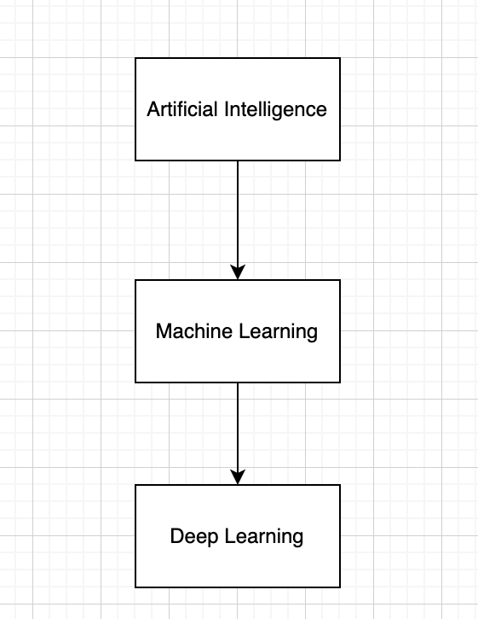
Figure 2.1: Overview of Machine Learning and Deep Learning

2.2 Machine Learning Fundamentals

Machine Learning (ML) is a part of artificial intelligence that allows the system to learn from the data by observing trends and making decisions without needing to be programmed. These models use large datasets to uncover relationships and improve their performance over time.

The growth of machine learning in modern intelligent systems, especially in areas such as data analysis, model prediction and automation (Kaur et al., 2024). When compared to traditional methods, machine learning offers more flexibility and saleability allowing it to adapt better to unstructured data. Machine learning is used in applications such as video analysis, speech recognition and recommendation systems, hence making it a key tool in intelligent content creation. This enables the foundation for the proposed system, which uses machine learning techniques to analyse and assess multimedia content.

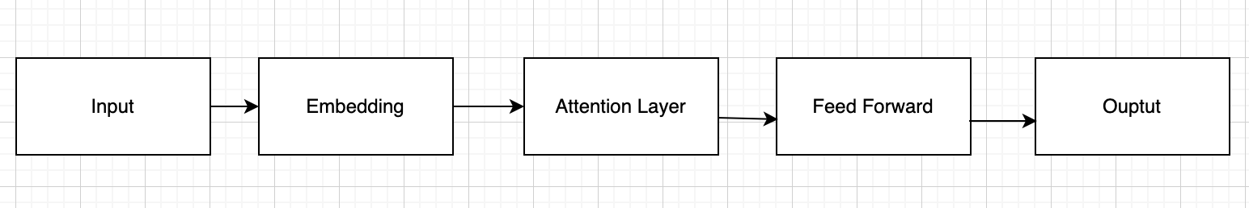
Figure 2.2: Transformer-Based Architecture Overview

2.3 Deep Learning and Neural Networks

Deep learning is an advanced subsection of machine learning using artificial neural networks with numerous layers to understand difficult patterns in data. These models are particularly useful when working with large datasets providing images, audio and video.

Allowing systems to automatically extract important features and reach high accuracy across multiple applications (Chen and Han, 2025; Tian, 2025) is an example of deep learning playing a crucial role in advancing artificial intelligence. It handles the issue of dealing with unstructured data by preforming better than traditional machine learning methods (Kaur et al., 2024).
Inside of deep learning architectures includes convolutional neural networks (CNNs), which are used for image and video processing, and recurrent based models, which are modelled towards analysing sequential data. In applications such as emotion recognition and video analysis this is commonly used.
This is especially important, deep learning models allow precise analysis of difficult data. These capabilities are important for uncovering emotional patterns within video content. This supports the development of the emotion clipping system

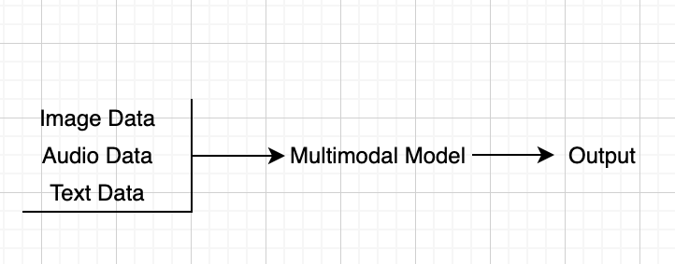
Figure 2.3: Multimodal Machine Learning

2.4 Next-Generation Machine Learning Architectures

Due to the recent progress made in machine learning more architectures have become influential allowing more scalable systems that are efficient

Transformers

One of the most crucial developments in artificial intelligence is transformers. They use attention mechanisms to assess data efficiently and get dependencies with long ranges inside of datasets. These model are used commonly in natural language processing, video analysis and generative AI systems.
Latest studies show that transformer based architectures have such a crucial role in pushing deep learning systems and enhancing performances across numerous tasks (Azizov et al., 2024).
The flexibility of these architectures makes them suitable for intelligent content creation tasks. In this study, they form the basis for handling large video datasets.

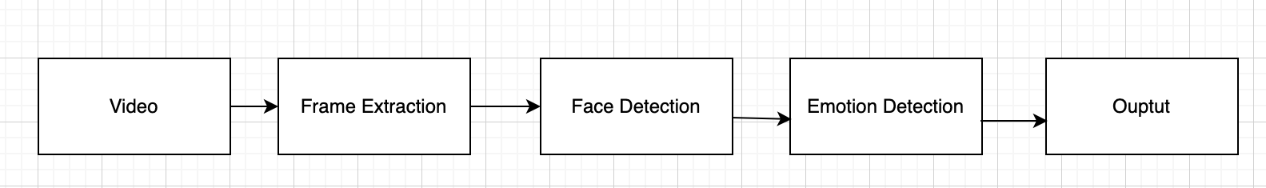
Figure 2.4: Emotion Recognition Pipeline

Foundation Models

Foundation Models are large machine learning models that are trained on huge dataset and adapted to perform a wide number of tasks. These models offer flexibility and scalability, allowing AI systems to handle multiple functions inside of a framework.
In a study by Bommasani et al. (2024 he showcases foundation models have greatly expanded the abilities of artificial intelligence by supporting a variety of applications including content creation and multimodal learning.

Generative Artificial Intelligence

Generative AI’s primarily focus is on making new content by learning and using patterns from data. These systems can produce text, images, audio and video, hence building its significance to content creation.

Generative AI allows systems to make original and good results from learned data structures. This changes AI from an analytical tool into a creative systematic tool that generates engaging content for users.

2.5 Multimodal Machine Learning

Multimodal machine learning combines multiple types of data such as visual, audio and textual information into a singular model. This approach helps systems better understand context and produce higher quality results.

Research conducted by Wang et al. (2024) shows that multimodal models can combine complex data structures to better performance in functions such as video analysis and content generation. By analysing these modalities together, these systems can better understand complex real world data. Studies also show that multimodal AI can greatly better video understanding by putting together numerous types of data (Zhang et al., 2024).
For this research emotion detection needs visual (facial expressions) and audio signals (speech patterns). This is relevant to the given system, as emotion detection puts numerous types of data together. The system can build a more accurate representation of user emotions within video content by merging different sources.

2.6 Emotion Recognition in Artificial Intelligence

Emotion recognition is an important element of intelligent content creation systems. There’s a strong focus on human emotions using computing methods.

These systems usually analyse facial expressions, speech signals and text to identify emotions. Latest studies highlight that deep learning has massive improved the accuracy of emotion recognition across a few types of data (Sharma et al., 2024).
In addition, emotion recognition in real time has been shown to work well in video-based applications allowing systems to detect emotion changes as they occur (Lin, 2024).
This is crucially substantial for this research, as it helps the system uncover emotional moments within video content. The ability to accurately pick out the relevant emotional state to the most engaging moment in the video. This supports the aim of the research, which focuses on taking out the most emotional engaging clip to improve viewer retention.

2.7 Video Processing and Intelligent Content Creation

Video processing refers to analysing and editing video data to extract useful information, this includes tasks such as detection of emotions during scenes, identifying key moments and generating short clips.
Modern AI systems apply machine learning techniques to optimise these process, reducing the need to edit manually. Emotion video clipping systems plans to figure out key emotional moments to transform them into short, engaging clips.
Research suggest that systems that are emotionally aware massively improves engagement from users in the social media world (Hussain et al., 2025). This is appropriate for the social media environments such as YouTube Shorts, TikTok, where short form videos are high popular. This can also be said for Instagram Reels where there is a growing demand for short videos as well.
These techniques play a huge part to the system, because they automate, detect and extract the important moments from the video. The systems aims to produce short clips that are engaging that match the current trends by adding emotion detection with video processing.

2.8 Summary

This chapter has uncovered and identified the key components that allow intelligent content creation, including machine learning, deep learning, next generation architectures, multimodal systems and emotion recognition. These progressions showcase how modern AI systems can understand and figure difficult data and produce meaningful results.
These advancements demonstrate how modern AI systems can analyse complex data and generate meaningful outputs. These ideas discussed in this chapters give the foundation for the given system, which combines these technologies to create short, emotionally engaging video clips. The next chapter will build up on the foundations by crucially reviewing existing research in the area.

2.9 Literature Review

Introduction

In recent years, there has been a sharp rise in AI model systems experienced in generating images, videos, texts and multimodal content. This growth is also showcased in a 2024 study by Yekta, who argues that GPT-4’s wide-ranging capabilities and its potential to share knowledge across disciplines represent a major step toward more general, human-like intelligence (Yekta, 2024). These systems now play a major role in how digital content creation is produced, consumed and modified, reformulating creative work in the process. AI tools in the past were only limited to completing tasks that were highly structured or simple, but machine learning architectures can now create high quality material and enhance original ideas, this is referred to as intelligent content creation.

This development is driven by newer machine learning architectures such as diffusion models, transformer models, and multimodal networks that offers more advanced facility. This is reinforced by Paul (2024) who reviews modern machine learning architectures used in next-generation wireless systems and notes how machine learning architectures give AI the ability to understand difficult and complex patterns, learn from massive datasets and construct content that would resembles what a human might make (Paul, 2024). Although lots of research and studies already investigate these technologies, the research is scattered across different places making it tough to understand the full field.

To better understand what is taking place in this field, this literature review will follow a thematic approach. It will explore five themes that are analysed in recent studies (Yekta, 2024). How Machine Learning Models Have Changed (Paul, 2024). The Changing Nature of Content and Creativity Due to AI (Lan et al., 2025). Where is Technology Headed Next? Collectively, these themes will showcase how next-generation machine learning architectures influence intelligent content creation and what it means for the future of digital content.

2.9.1 How Machine Learning Models Have Changed

Machine learning has progressed through many major architectural stages, moving from simplistic, manually made models to extensive systems which are competent in learning complex studies from data. Early access relief heavily on features that were handcrafted, statistics that were assumed, and limited data models. These systems often struggled strained to obtain high-dimensional patterns because of computational resources that were restricted and limited data sets. Lan et al. highlights that early machine learning models were narrow in the expressiveness, making it erratic for many real word learning tasks (Lan et al., 2025).

The evolution of deep learning signalled a definite turning point. Improvements in hardware, increased data availability, and development of multilayer neural networks to learn hierarchical features directly from raw data. Convolutional Neural Networks which are deep learning model used to automatically find patterns in images (CNN). Recurrent Neural Networks which are deep learning model for data in sequences where the order matters. Autoencoders which learn patterns from data without needing labelling examples. CNNs, RNNs and autoencoders made it possible for models to identify deep features hence reducing the need for manual feature engineering. As shown in biomedical studies by Sharma et al. deep learning architectures enable systems to uncover patterns not easily recognisable in complex data structures that earlier models could not process and detect (Sharma et al., 2024).

As neural networks grow deeper and trained on larger datasets, machine learning began shifting towards scaling-driven program. Prabhu et al. showcases the increase in model size, dataset volume and computational power led to a massive performance leap hence helping deep learning evolve from a specialised technique into a dominant framework that can be witnessed across multiple areas (Prabhu et al., 2024). These transformations established the basis for modern architectures such as transformers and diffusion models. Unlike earlier models, the development of such systems is portrayed by its quick version, open-source collaboration and increasingly difficult training pipelines. Castaño et al. shows that today’s models have evolved to be shaped by large ecosystems rather than static algorithmic designs, this marks a significant departure from traditional machine learning development models (Castaño et al., 2025).

Together, these changes show how machine learning has transitioned from rigorous, handmade systems to adaptative, scalable architectures that power most of today’s advanced AI models

2.9.2 From Traditional Models to Deep Learning
Traditional machine learning is built on statistical models and rule-based techniques. These methods worked well for tasks with a well-constructed organised dataset but it does lack the space to discover deeper relationships. According to Lan et al. notes that the architecture and the computational environment were limited which had an effect on the performance of these early systems (Prabhu et al., 2024).
Deep learning has massively reshaped this landscape. Once the introduction of CNN’s came in these models gained the ability to learn visual and spatial hierarchies. In research found by Sharma et al. it demonstrates how CNN-based representations drastically improved analysis in biomedical settings by taking out structures of meaning from raw or semi-structured data (Castaño et al., 2025). RNN’s and LSTM models expanded learning into sequential domains such as speech, text and time-series forecasting.

Other architectures including autoencoders and encoder-decoder models-enabled models to compress and reconstruct data, forming the early foundations of modern generative system. According to Prabhu et al, these deep learning frameworks introduced end-to-end training pipelines that replaced manual feature engineering with more flexible, data-driven processes (Prabhu et al., 2024).
This shift toward deep, data-driven models provided the base foundation for the highly expressive systems that followed.

2.9.3 The Rise of Transformers and Diffusion Models
Transformers introduced a new mechanism for modelling relationships within data by using self-attention machines. This design allows models to recognise long-range dependencies more effectively and without the limitations of strictly sequential processing Chen and Han argue that transformers revolutionised fields such as language, engineering, and scientific computing by enabling parallel processing and global context modelling—advantages that earlier architectures lacked (Chen and Han, 2025).
Scaling transformer models resulted in large language models (LLMs) such as GPT, PaLM, and LLaMA, which demonstrated strong generalisation, reasoning, and cross-domain capabilities. These models no longer required task-specific training, reflecting a huge change in how machine learning systems are designed and used.
At the same time, diffusion models emerged as a powerful generative framework. Instead of adversarial training, diffusion models generate content through iterative denoising, leading to more stable training and higher output fidelity. Castaño et al. (2025) note that the quick adoption and improvement of diffusion models across open-source communities show how adaptable and modular these architectures have become (Castaño et al., 2025).
Together, transformers and diffusion models represent some of the most significant architectural breakthroughs in modern machine learning, enabling major advances in generative performance, modelling power, and multimodal integration.

2.9.4 The Changing Nature of Content and Creativity Due to AI
As machine learning architectures have advanced, their influence has extended past technical performances into the world of creativity. While Section 1 outlines how models evolved from shallow systems to deep, scalable architectures, this section explores how those same architecture changes what counts as “creative work” and how humans participate in it. In contrast to earlier generations of AI which were constricted to smaller tasks and lacked any resemblance of flexibility, these modern systems such as large language models and diffusion models take on an active role in making artistic, literary, and design-focused outputs. Their abilities have produced a huge debate over whether AI broadens human creativity, challenges it, or alters it into something essentially new. Ivcevic argues that AI should be viewed not as a replacement for human creativity, but as a tool capable of expanding the range of possibilities available to users (Ivcevic, 2024)

2.9.5 AI as a Tool for Enhancing Creative Possibilities
Recent research argues that AI can enhance human creativity by improving productivity, helping idea generation, and bringing down the barriers to producing creative work. Zhou and Lee’s large-scale study on text-to-image diffusion models showcases that generative AI can immensely build artistic productivity and even improve peer evaluations of creative results by allowing users to explore new ideas more efficiently . Rather than replacing creative effort, the study suggests a symbiotic relationship in which humans can provide analysis, judgment, and clarification, while the AI assists with rapid generation and decisions (Zhou and Lee, 2024).
Similarly, Pandy’s review of generative AI reinforces this shift, highlighting how tools such as GPT models and diffusion systems support creativity across industries by automating low-level tasks and enabling creators to focus on higher-level critical work (Pandy, Pugazhenthi and Murugan, 2025). This stands in contrast to earlier machine learning approaches described in Section 1, where fixed architectures and reserved data prevented AI from contributing in a meaningful manner to open-ended, imaginative tasks. Today’s models gain from scalability and multimodality, enabling them to make flexible, human-like content and in turn helping creative work rather than limiting them. This aligns with broader findings that AI can enhance idea creation by helping users explore possibilities that fall outside their usual creative patterns. Doshi et al. adds that generative AI can improve individual creative performance although sometimes at the cost of reduced idea diversity, especially when users converge on similar model generative patterns (Doshi et al., 2024)
Educational research also identify AI’s potential for developing creative thinking skills while the role of a human creator is changing. Habib et al. show that generative AI systems specifically large language models can support divergent thinking exercises and help students generate more flexible and diverse ideas when used as part of structured activities (Habib et al., 2024). This demonstrates a clear contrast with earlier AI systems that lacked the ability to participate in idea creation at all, showing how architectural innovations translate into new creative opportunities for learners and practitioners.
Marrone et al. further argue that when tools like ChatGPT or AI image generators take over creative workflow such as drafting, figuring out concepts, or gathering information, humans focus more on sense-making, evaluation, and high-level decision making (Marrone, Cropley and Medeiros, 2024). In this sense, creativity is becoming partially outdated, with humans acting as directors or editors rather than sole authors. This shift framing aligns with the transition discussed in Section 1: as architectures progress and evolve, AI’s role shifts from passive computational tools to dynamic interaction and collaborators in work.

2.9.6 Challenges, Tensions, and Shifts in Creative Roles
Along with these benefits, researchers also establish important issues and tensions surrounding AI’s growing involvement in creativity. Brem and Hörauf suggest that as generative AI becomes more accessible it creates uncertainty about the future role of human creativity, raising concerns about how authentic and original the work is and also the potential of relying too heavily on AI-generative ideas (Brem and Hörauf, 2025).
These concerns go stand in contrast with earlier discussions of machine learning, which mainly focused on performance limitations; the argument has now shifted to cultural, ethical, and abstract implications made possible only because modern architectures have become powerful enough to have an influence on human creative identity. Another concern relates to innovation. Zhou and Lee report that while peak innovation increases among some AI-assisted creators, average innovation tends to decline over time because users lean towards familiar styles made by common models (Zhou and Lee, 2024). Holzner et al.’s systematic review supports this notion, noting that although generative AI can enhance creative output quality, it often leads to lesser originality when users rely too heavily on model-generated templates (Holzner, Maier and Feuerriegel, 2025). This suggests that even though AI systems can expand the idea space, they may also lead to more creative output, an effect that was absurd with earlier, less manageable architectures that didn’t have generative ability altogether.
At a broader societal level, several authors state that AI-generated content challenges established creative and cultural conventions around authorship, ownership, and evaluation. Marrone et al. argues that since AI cannot separately meet the basis of human creativity such as creating genuinely novel and effective ideas, its outputs should be understood differently, with humans remaining crucial in defining creative value (Marrone, Cropley and Medeiros, 2024). This reinforces the idea, talked about in Section 2, that while models are more powerful than ever, they still operate within boundaries shaped by training data and algorithmic constraints.
Finally, studies examining creative education state that applying AI to creative learning requires careful guidance to ensure students increase judgment, critical thinking, and originality rather than relying wholeheartedly on automated results . Habib et al. shows that although AI can enhance divergent thinking, it also risks reducing students’ creative confidence if misused or over-trusted (Habib et al., 2024).
Together, these studies determine that advancements in machine learning architectures particularly transformers and diffusion models have not only significantly bettered technical performance, but essentially changed how content is produced, evaluated, and accepted. However with the earlier architectures mentioned in Section 2, today’s models actively compete in creative thinking, promoting new ways of collaboration as well as new challenges. AI’s role in creativity is therefore neither purely supportive nor purely disruptive; instead, it represents a shifting partnership in which human skill and machine capability continually reshape each other.

2.9.7. Where Is Technology Headed Next?
Advancements in modern machine learning is shifting AI systems that work not only as content generators but also as flexible partners capable of combining with humans across creative, professional, and analytical duties. With complex models such as model scales, multimodal capabilities and growing forms of autonomous thinking the next stage of AI is expected to work independently, make decisions and shift into our everyday workflow. This section will build on the architectural developments highlighted in Section 1 and the creative transformations discussed in Section 2, showing how these technologies may soon change both the technological landscape and the wider creative ecosystem.

2.9.8 Emerging Capabilities and Future Directions
Recent studies predict that AI systems will advance in areas such as long-term memory implementation , personalised model fine-tuning, and more efficient generative pipelines. Salimans outlines how future models will rely on frequent reasoning loops and improved development strategies to create more consistent, context-rich findings (Salimans, 2024). Meanwhile, Bai et al. describes the rise of agentic AI systems capable of devising plans, acting across digital environments, and autonomously completing difficult workflows (Bai et al., 2024). This leads into a future where AI not only makes content but rearranges multi-step tasks in partnerships with humans

2.9.9 Ethical Considerations and Remaining Limitations
However, fast progress introduces serious challenges. Floridi warns that progressively autonomous AI systems impede accountability and transparency, especially when outputs influence high-risk decisions (Floridi, 2024). Lorenz-Spreen et al. argue that generative models may lesen information ecosystems by allowing realistic misinformation and reducing trust in authentic media (Kovačević et al., 2025). In addition, Kovačević et al. highlights issues around dataset bias, limited access, and the total cost of large-scale model training (Kovačević et al., 2025). As AI system grow these issues show that ethical governance must evolve at the same pace as technological innovation.

2.9.10 Evaluation and Findings
Across this literature review, clear patterns appear regarding the evolution and implications of next-generation machine learning architectures. Firstly, the technological shift from traditional shallow models to deep architectures has immensely increased AI’s ability to understand complex patterns, produce high-quality content, and operate across multiple modalities. This transformation has made AI more flexible, responsive, and adjust to real-world creative and analytical tasks.
Secondly, findings from Section 2 show that AI’s influence on creativity is varied. On one hand, models such as large language models and diffusion systems significantly improve creative workflows by supporting idea generation, increasing productivity, and allowing users to explore new directions. On the other hand, heavy reliance on automated systems does spark concern, and lesser human involvement in early-stage creative work.
Finally, Section 3 reveals that the direction of AI is going to be defined by the increased autonomy, deeper customisation, and advanced multimodal usage. However, these benefits are closely tied to challenges involving ethics, misinformation, lack of transparency, and environmental impact.
Overall, the result indicate that while AI is becoming an crucial creative and analytical partner, its usage requires careful control, thoughtful design, and ongoing evaluation to ensure responsible use.

Conclusion
This literature review shows us the major and quick progress in machine learning especially deep learning, transformers and diffusion models have reshaped not only how AI system learn and how the content is created. Early models were very limited and didn’t showcase enough compared to new models now. The newer can handle complex patterns, work across multiple modalities while being able to generate high-quality outputs. These capabilities have changed machine learning architecture from fixed computational tools to active collaborators in both creative and analytical tasks.

Chapter 3 – System Analysis

3.1 Introduction:

This chapter will examine the emotion detection clips generator and explains what the system will do. Supporting intelligent content creation is the aim of the system, once it identifies peak emotional moments inside of a video restrict to five minutes or less because of how long it takes to process the video frame by frame and converts them to short clips. This supporting the aims of the thesis, which is examining how next-generation machine learning architectures can enable intelligent content creation.

The aim initially was for the system to be ran on my MacBook, but I encountered heavy technical issues changing it to be ran on a Dell laptop. This uses Python tools and libraries. Since the system does go through a lot such as GPU processing, processing speed, storage, emotion detection and the complexity of the model must be assessed. Through having a system like such, its aim isn’t to replace the role of video editors but to make a sample system that aids the editing process by detecting emotions and reducing the workload on long winded video content. This system can also help upcoming content creators who can’t pay for high end editors.

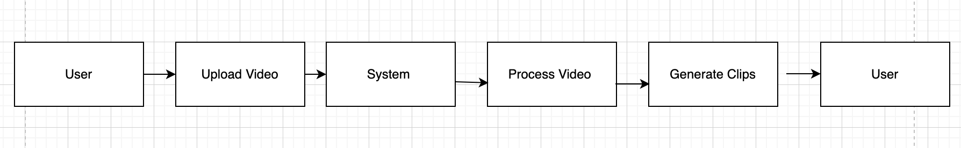
Figure 3.1: User Interaction Flow

3.2 Problem Analysis:

Video editing usually has the process of someone watching long parts of footage, figuring out moments and interest, cutting sections and using these interesting clips for social media exposure. This can be tedious and time consuming, especially if creators are working with long videos, podcasts, gaming streams, interviews or reaction videos. Tie that with these creators/editors needing to find intriguing moments or peak emotional sections that are also emotionally engaging such as sadness, laughter, happiness etc.

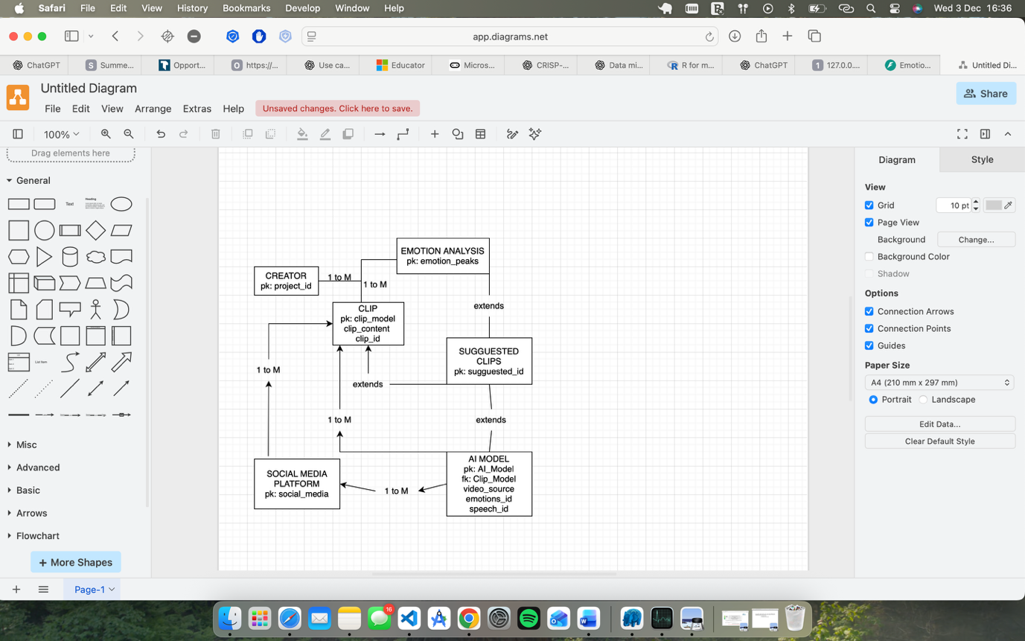

This given system aims to be solution to this problem by using emotion detection as a perquisite for clip automation starting off on a small scale first before expanding. The system examines the vide, identify peak emotional moments and return clips on those moments. This plans to be extremely useful for creators who use platforms such as TikTok, YouTube Shorts or Instagram Reels.
Identifying engaging or interesting moments is crucial in this system, hence the push for emotional scores and timestamps in the videos are important as they are key factors in the suggested clips given. Clips should be returned to the user because the system identified a strong emotional signal it deemed as engaging or interesting from its high emotional score. Emotional detection becomes the key mechanism for the system.

3.3 Project Scope:

The scope aims to develop a prototype emotion clips generator. The system pushes to focus on detecting emotions from video frames and using the result to produced short clips. The project will be tested and developed from a Dell laptop.

What system will include:
- Video link input
- Frame extraction
- Face Detection
- Emotion classification
- Emotional peak identification
- Clip generator
- Output for clips
Its aim isn’t to replace the role of video editors but to make a sample system that aids the editing process by detecting emotions and reducing the workload on long winded video content. It will not guarantee every clip will be “viral” because there are many factors that creates that narrative such as your audience, caption, timing of posting, sounds and trends. The system pushes itself to support short form content by finding emotional moments.
The primary target users of the systems are content creators and editions who work with video content and look to speed up or lessen their workload. User may vary from:
- Youtubers,
- TikTok creators
- Twitch streamers
- Podcast editors
- Social Media Managers
- Students
Having access to advanced editing software may not always be available, this aims to bridge that gap as an alternative. As it is running on a Dell laptop, it doesn’t require elite knowledge of machine learning.

3.4 User Scenario:

A user records a 5 minute reaction video and want to create short clips for TikTok or YouTube shorts. Instead of having to watch the whole video, the user uploads the YouTube link into the emotions clip generator. The system will then extract frames from the video, find emotion peaks, scores the emotion with timestamps and identify the strongest emotions. It will then create short clips around the timestamps. The user can then review the created clips and have an automatic caption given underneath and can choose which platform to upload unto.

3.5 Functional Requirement:

Functional Requirement
- The system must allow the user to use a YouTube link
- The system must extract frames from the video
- The system must classify the emotions from the video
- The system must identify peak emotions
- The system must generate short clips from the video
- The system must save the clips
- The system must give generate caption ideas based on the short clips

Explanation
- The is required, with video the system can’t detect emotion or clipping
- Emotion detection is done using visual data, frame must be analysed
- Core function of the project, emotion such as happy, sad label the emotional state of the video
- Every emotion shouldn’t be clip[ed, just where the highest emotional peak is
- This turns the emotions into short usable content
- Output clips must be saved so user can review after processing
- Helps user not have to create caption for clip, speeds process for thinking

Chapter 4 – System Design

4.1 Introduction:
This chapter shows the designing process of the emotion detection clip generator. After the system analysis outlined in Chapter 3, the design explains how the system will take in the video, detect the emotional state and create short clips automatically. The purpose of this chapter is to bring in the analytical phase into a system that is structured which can be tested.
The aim of this chapter is to bring closer the gap between theorical analysis and practicality by labelling and defining the systems components and pipeline process. This design makes sure the system is, efficient and suitable for testing within the computing limits of a dell laptop and its environment.

4.2 System Overview:

The system automates the process of identifying interesting emotional moments withing a video and turn them into short clips which can be shared onto several platforms. This system works through a pipeline that processes both visual and textual data.

By extracting frames from a video the system can identifying any emotional expression and detecting facial expression. These moments can then be turned into short generated clips, which can be improved upon further with captions and prepared for social media attention.
Workflow:
This is the process the pipeline follows:
Video Input – Frame Extraction – Face Detection – Emotion Detection – Emotion Scoring – Clip Generation – Clip Result
Each stage of this pipeline performs specific tasks, ensuring the system is easy and structured.

4.3 System Architecture:

The system follows through with a pipeline based architecture, this allows the data to follow through sequentially. This becomes more suitable for video processing systems, as each stage needs to be completed before moving onto the next one.

The architecture is flexible, allowing each individual component to be improved upon and tested.

Models in the Architecture:

• Model Input
- Accepts video links from the user if less than 5 minutes
- Validates/Denies YouTube link
• Preprocessing
- Extracts frames from video
• Face Detection
- Detects faces in each frame
• Emotion Detection
- Classifies emotions using a pre-trained model
- Outputs emotion labels and confidence scores – uses a confusion matrix
• Emotion Scoring
- Stores timestamps with corresponding emotion scores
• Peak Detection
- Identifies moments with high emotional intensity
• Clip Generation
- Extracts short clips around emotional peaks
• Output Module
- Saves generated clips to user storage
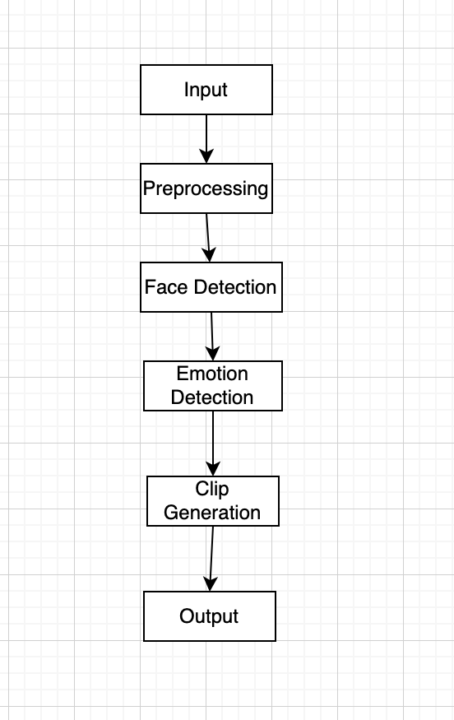
Figure 4.1: System Architecture

4.4 Design Justification:
This pipeline design was picked because it its simple which gives each component of the system a chance to be improved upon and get tested. This is especially important for this project, as the Dell laptop has limiting power to process the video.
Using pre-trained models reduces needing expensive training for the system, allowing it to be more practical. Using frame extraction reduces the need to process whilst managing and maintaining good accuracy for identifying emotional peaks. This can also allow the system to be flexible, efficient and scalable for cases in the real world.
Key decision include:
Pipeline Structure – Stages are concise and the process of debugging and testing is simplified
Pre Trained Models – Computing requirements are less as training large datasets are avoided
Frame Sampling – The number of frames are reduced while maintaining accuracy during frame processing
Local Processing (Dell) – Performance is restricted but privacy is ensured and there is less reliance on cloud infrastructure (iCloud)
Attributes such as efficiency, scalability and practicability within the hardware is more balanced inside of the design.

4.5 Data Flow Design:

The flow of the design shows its structural process from raw input to final output.

Step by Step Process
- Video Input
  - Video link
- Frame Extraction
  - Video is converted into image frames
- Face Detection
  - Frames filtered to include only those with faces
- Emotion Detection
  - Emotions are given to each frame
- Emotion Scoring
  - Confidence scores assigned with timestamps
- Peak Detection
  - High-emotion peaks are identified
- Clip Generation
  - Emotions are then converted into short video clips

4.6 Security and Privacy Considerations:
Due to the system, video processing will be taking place on the Dell laptop, the risk of data privacy are reduced as these videos are not being uploaded to any external servers, in return it means personal content is secure. There is less risk of any data breaches but in the future if a move to a cloud based happened more security measures will have to take place on cloud based implementations.

4.7 Summary:
This chapter showcases a design structure for the emotion clips generator through the use of its architectures and models. This pipeline model allows the video data to be processed effectively within the Dell’s specifications turning raw video data into short interesting clips. Important decisions such as frame sampling and the use of pre training models ensures safety and performance accuracy.

Even though the Dell laptop environment is limited, key decisions such as frame sampling and using pre trained models were incorporated together to create better detection accuracy. Having an emotions timeline being built and peak detection allows the system to be classified and categorises the most emotional engaging moments within a video.
The architecture has individual components which can be tested and improved upon, the primary aim of the system is to focus on its core functionality but it also takes precedence in improving emotion accuracy, processing in real time and uploading to social media tools.
This chapter shows the basis for the next stage of development, where we show how the system was built using Python and other tools and technologies.

Chapter 5 – Implementation

5.1 Introduction:
This chapter explain the process of the implementing the emotion detection clip generator established from the system outline given in Chapter 4. The system was produced using Python, through the use of this it allowed users to use YouTube links shorter than 5 minutes, process the video using computer vision and techniques from machine learning and generate short clips based on peak emotions. The clips are further enhanced by auto generated captions and publishing on platforms such as YouTube Shorts, TikTok and Instagram Reels.
Python was used to make the backend user friendly for interface interaction and scalability.
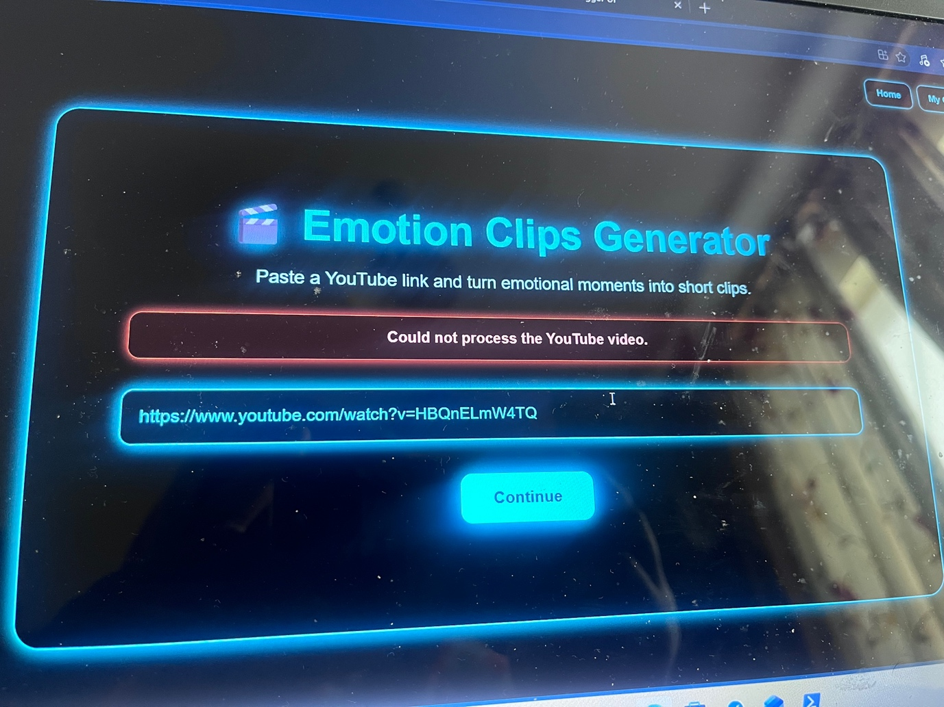

5.2 System Overview:
The systems operates as a web application that focuses on two main components:
- Frontend – User interface for input, output and result
- Backend – Processing that follows a pipeline for video analysis and generating clips
When a user uploads a YouTube URL through the frontend, the workflow begins and follows the pipeline. The backend validates the video, process it through a number of stages and then returns the generated clips back to the user.

5. 3 Development Tools and Technologies:

5.3.1 Programming Language
The main programming language used was Python, it was chosen as it could support machine learning, computer vision and backend web development. Python allows integration of libraries such as OpenCV, DeepFace, MoviePy and Whisper which were crucial for video processing and emotion detection. Lower-level languages improve performance through libraries that were integrated
- Python 3 was used to develop the backend as it was deemed a strong system that could enable machine learning, video processing and API development
- JavaScript was used in the frontend (React) to interactions from users, an example of this is when user submit YouTube links
- HTML/CSS was used to structure and style the frontend with the aim of users having a positive user experience
- Shell tools was used on the Dell line as it executed command line operations from FFmpeg and yt-dlp for video processing functions
Backend
• FastAPI was used to build RESTful APIs
• This was used for
- High performance
- Python Machine learning libraries are built easier
- Support for video processing
Frontend
React / Next.js used for:
- User input interaction
- Showing generated clips
- Publishing buttons tools

Important Libraries
• Yt-dlp
- Used to download YouTube links less than five minutes
• OpenCV
- Used for extracting frames and processing images
• DeepFace / FER
- Used for detecting emotions from facial expressions
• MoviePy / FFmpeg
- Used for video editing and generating short form clips
• Whisper
- Used for automatic speech-to-text caption clips
• NumPy / Pandas
- Used for handling emotion data and timestamps

5.4 System Architecture Implementation:
The system follows a pipeline architecture, each stage must process data before moving onto the next stage

Pipeline Steps:
- Input YouTube link
- Validates video link
- Downloads video
- Extract frames
- Detect faces
- Detect emotions
- Build emotion timeline
- Identify emotion peaks
- Generate clips
- Add captions
- Return results


This design improves scalability and allows each component to be updated independently and work cohesively.

5. 5 Backend API Design:
RESTful endpoints are used to structure the backend

Main Endpoints
- POST /analyse
  - Accepts YouTube URL
  - Starts processing pipeline
  - Returns job ID or clip results
- GET /clips/{job_id}
  - Returns generated clips
  - Says whether its successful or failed

Publishing Endpoints
- POST /publish/YouTube
- POST /publish/TikTok
- POST /publish/Instagram
The purposes of these endpoints are uploading these clips to social media platforms using their APIs.

5. 6 Emotion Timeline Construction:
The system will create an emotion timeline once each emotion is categorised. This will explain how intense each emotion might be through the video. Once that is achieved this section predicts how long this emotional behaviour will carry out for and frame each processed frame.
Each processed frame is connected to:
- A timestamp (coming from the frame index to the end frame rate)
- Emotion Probability Scores
These values are stored in a structured format, typically in a dataset that is time sensitivity. This allows the system is able to track emotional movements throughout the video duration. Also to reduce noise made by facial expressions deeming to be inconsistent moving averages are used to across multiple frames. This removes any sudden rises in emotion detection created by lighting changes or detection errors.

5.7 Peak Detection:
This is a crucial part of the system is the emotion detection, this determines whether if the moment is engaging and highlight worthy.
Ranking
Emotions are ranked based on:
- Intensity of emotion
- The duration of the emotional segment
- How consistent the emotion is
Clip Selection:
The highest ranking emotion is used for clip selection

5.8 Clip Generation:
When it comes to converting emotions into short interesting clips, this means we have entered the clip generation stage. The system extracts clips once peak timestamps have been found centring this clips around each point of interest. When the time peak is active a segment of 10 to 15 seconds is created. In certain cases if a segment of 30 seconds occurred then, the clip may run from 25 to 40 seconds. Ensuring the emotion has enough content surrounding it.
To do this extraction video processing tools like FFmpeg and Moviepy were used, they allow precise control over the boundaries of each clip created. This means the clips don’t overlap and limits the number of clips created so quality is maintained over quantity.
In addition to this clips are created and seen in a vertical (9:16) aspect ratio to meet upload requirements for platforms such as TikTok, YouTube Shorts, and Instagram Reels.
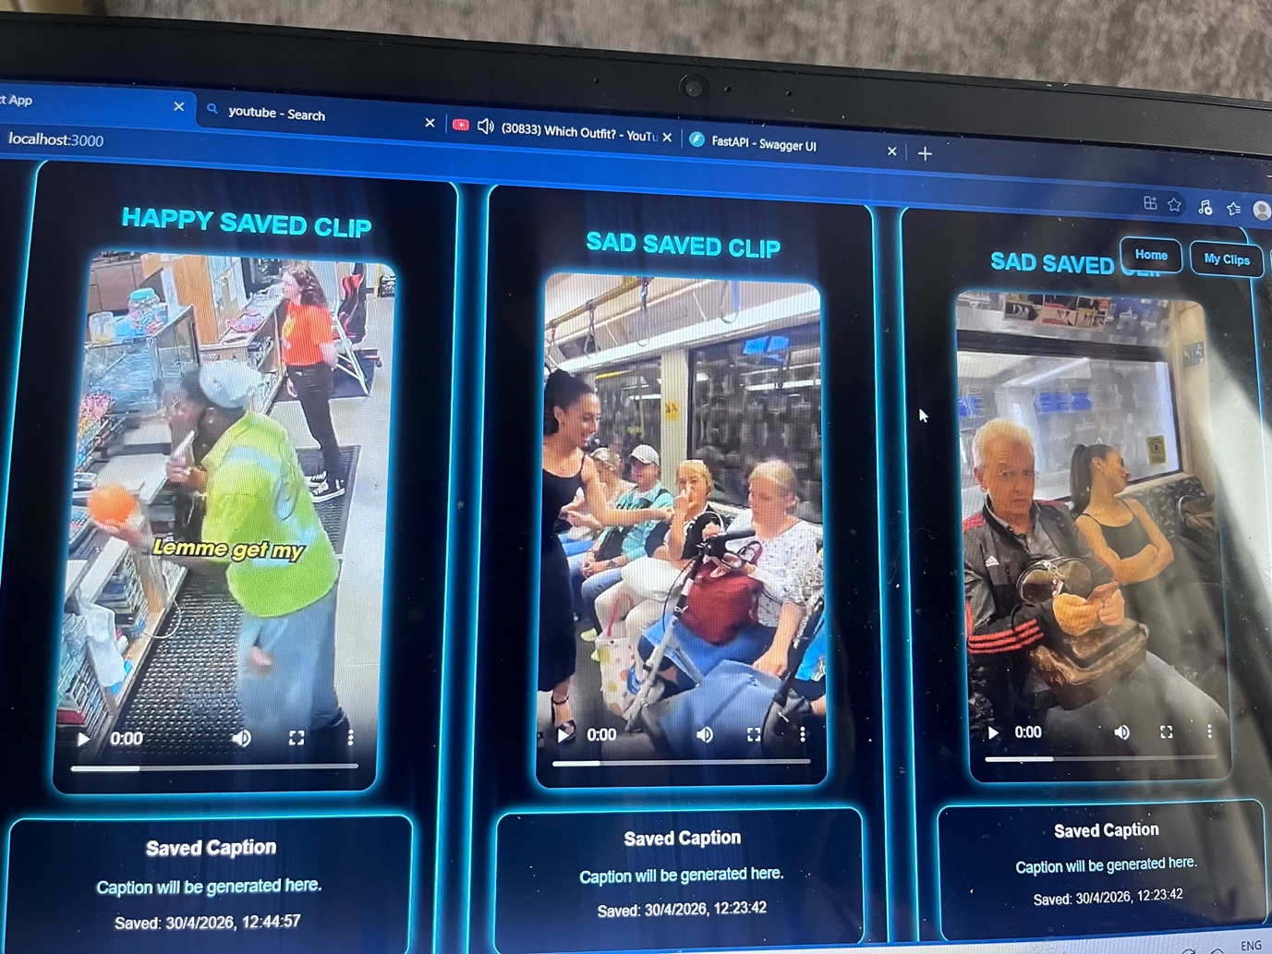


5.9 Caption Generation:
The creation of caption generation used speech to text methods. The system will process and withdraw audio from the video using pre trained models such as OpenAI Whisper to create a transcription. This transcription is in accordance with the timestamps, making both the video and caption to be matched accordingly. Afterwards the captions and put over the clips created using the rendering tools. Simple features to push forward making the caption generated look better such as style in regards to font sizing, positioning all to improve readability, accessibility and better engagement to viewers.

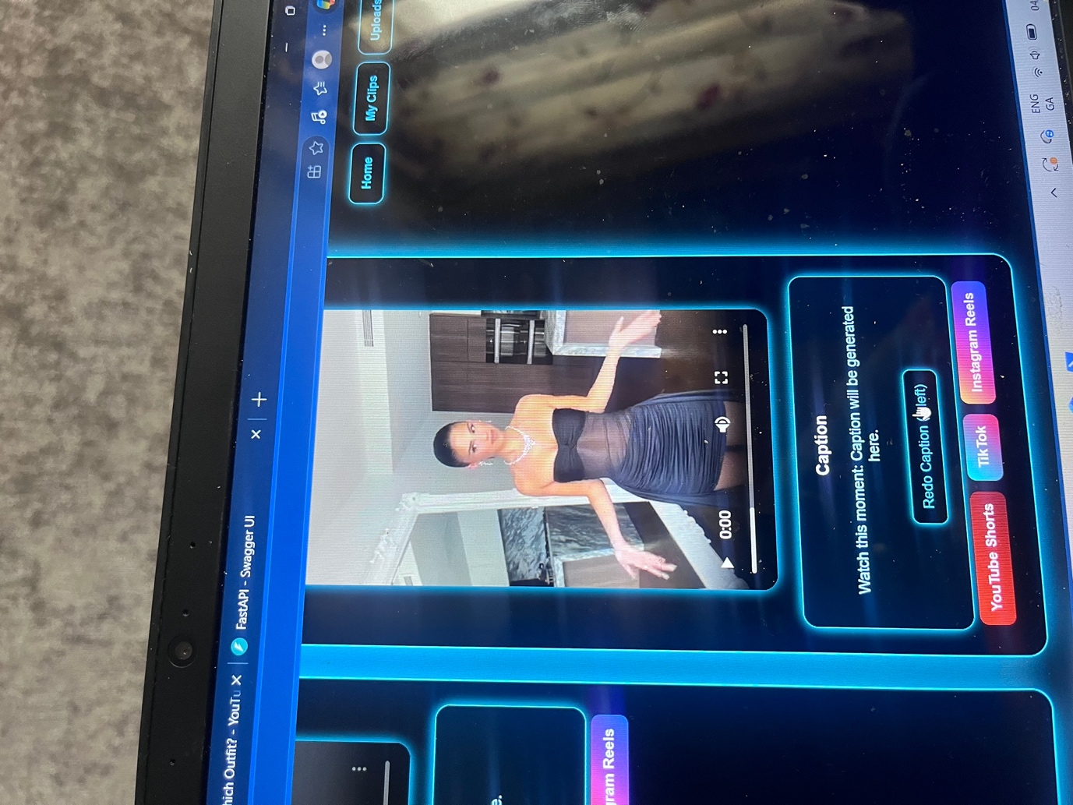

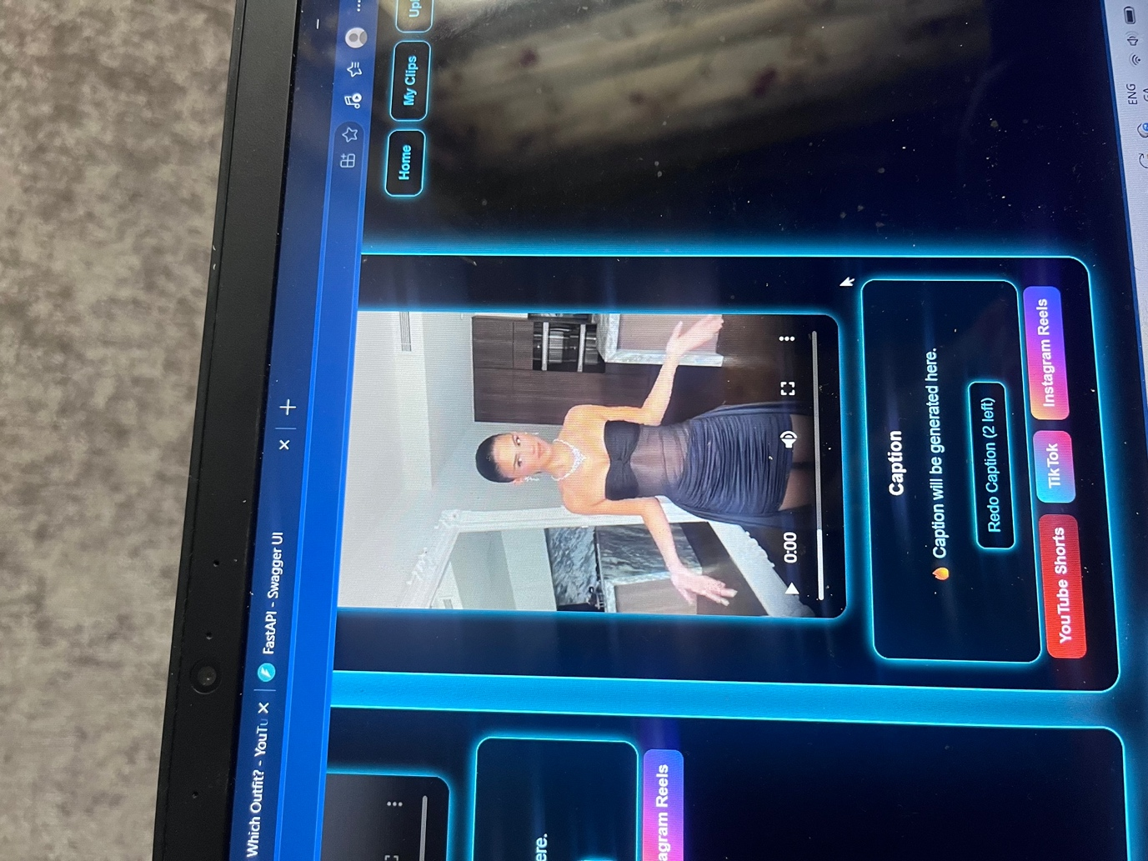

Chapter 6 – Testing and Evaluation

6.1 Introduction:
This chapter details the phase of testing and evaluation of the Emotion Detection Clip Generator system. The purpose of testing is to ensure that the system works, also meeting the requirements stated in chapter 3 and ensuring it performs reliably.
The testing was done across numerous components of the system such as the emotion detection, clip generation, caption generation and video validation. To test for system accuracy and usability functional and non-functional testing had to conducted.

6.2 Testing Strategy:
The testing stage followed a set structure to prove each stage of the pipeline separate and together as a full set.
Types of Testing Used:
- Functional Testing – verifies the system works together
- Integration Testing – ensures the pipeline stages works together
- Usability Testing – to evaluate use
- Performance Testing – measures processing time and efficiency
Each testing had to be done separately before testing the full pipeline.

6.3 Functional Testing:
Functional testing was conducted to make sure each feature works. But two fails occurred the emotion labels generated, not every emotion was clipped it incorrectly labelled for example neutral emotion as happy. Also caption generated failed too it said it couldn’t process the caption meaning the speech to text did work but couldn’t translated to use the transcript to generate the caption.

Table 6.1: Functional Test Cases

Test Case ID | Description | Input | Expected Output | Result
ID 1 | Valid YouTube link | <5 min video | Accepted and processed | Pass
ID 2 | Invalid link | Random URL | Rejected | Pass
ID 3 | Long video | >5 min video | Rejected | Pass
ID 4 | Emotion detection | Face video | Emotion labels generated | Failed
ID 5 | Clip generation | Emotional peak | Clip created | Pass
ID 6 | Caption generation | Audio present | Captions generated | Failed
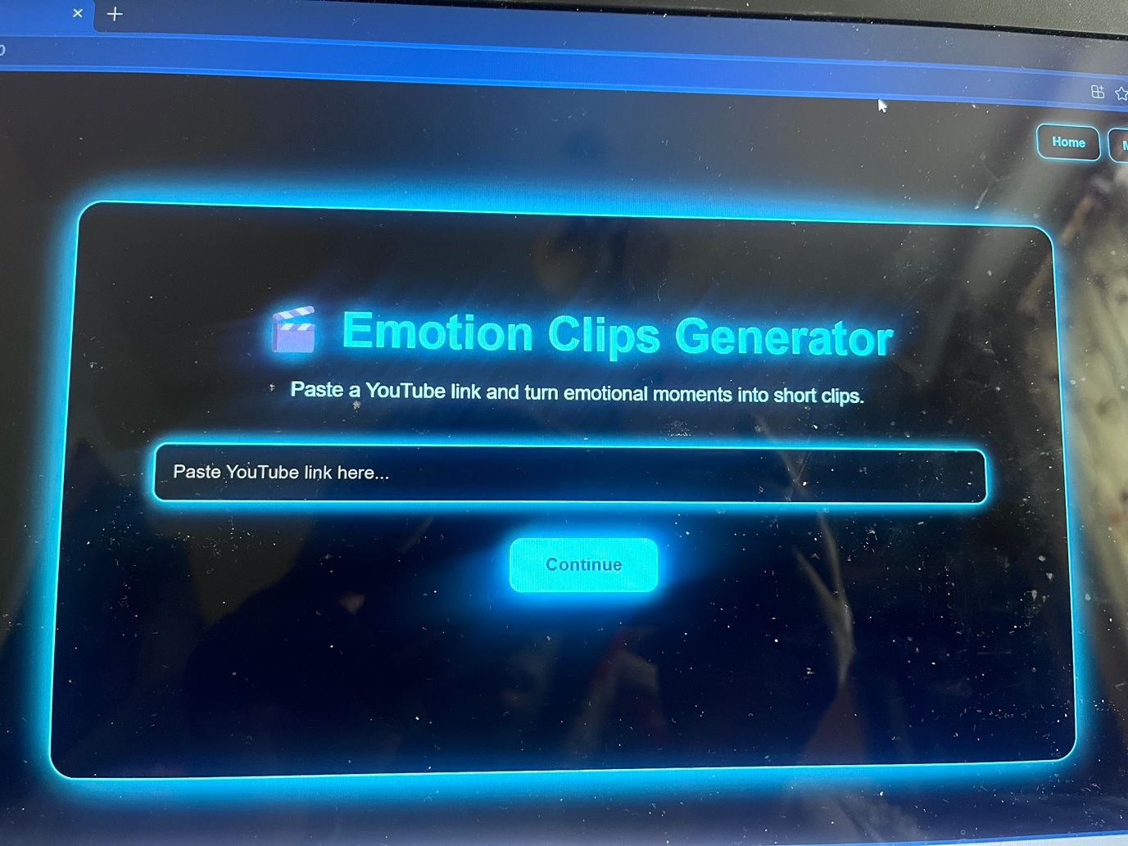





6.4 Emotion Detection Evaluation:
Emotion detection was done on videos with visible facial expressions. In the coding section DeepFace.analyze() was used this means a pretrained model look at the face and picks an emotion and outputs a label. The model has been trained on thousands of faces that are labelled. The model will find a face, then looks at facial features such as eyebrow, facial tension, mouth shape. The model has patterns it has learned such as smile + raised cheeks= happy, wide eyes + surprised brows = surprised or tight lips + furrowed brows = angry.

It then calculates the scores, before then deciding about the highest value. The system doesn’t use a confusion matrix during its runtime. It justifies its choice by math and learned patterns.
{
"happy": 12.3,
"sad": 68.9,
"angry": 4.1,
"fear": 2.0,
"neutral": 12.7
}
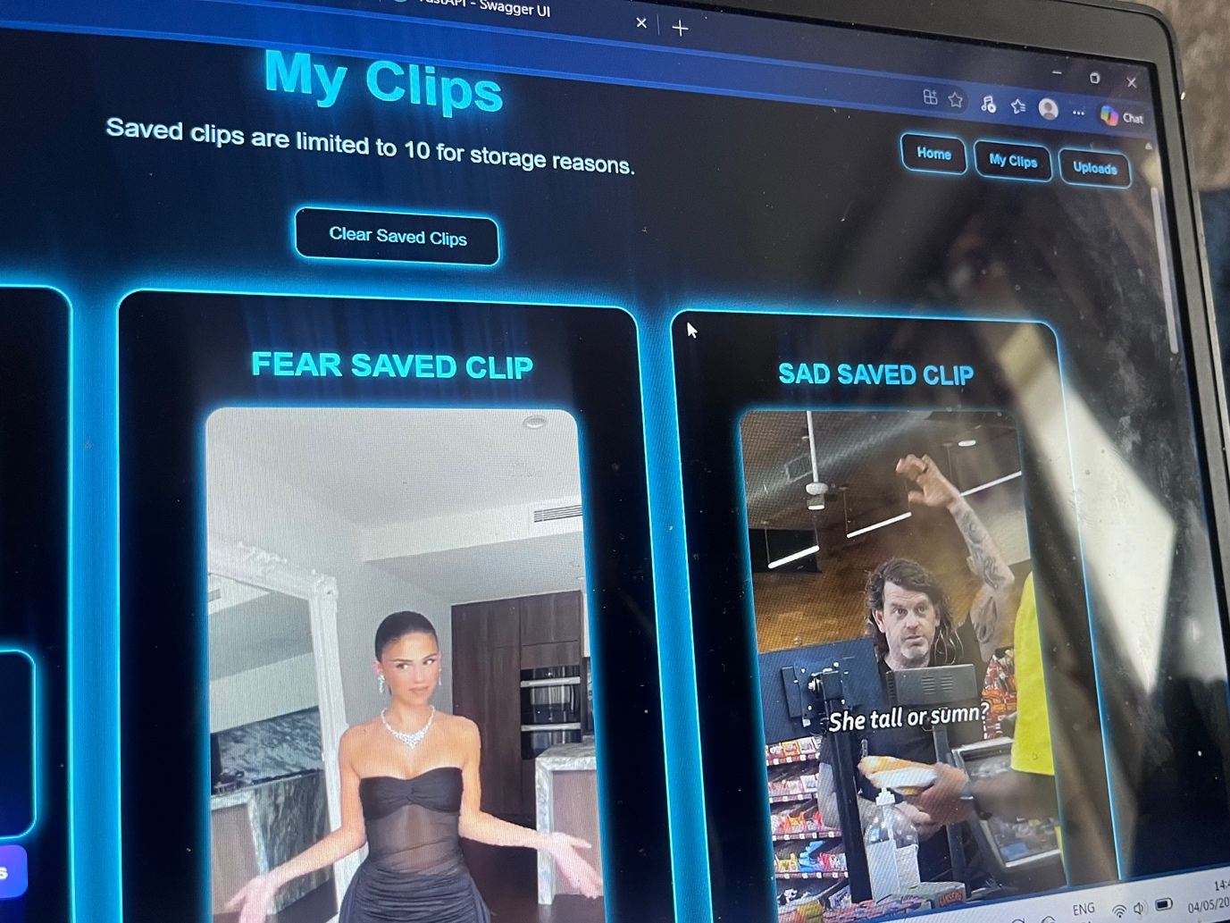


From research it at times has weak detection because it doesn’t identify a clear facial expression, there is multiple faces or there is blurry frames. To make it smarter you can ask it to ignore neutral emotions or to accept only strong defined emotions.
6.5 Emotion Timeline and Peak Detection:
The system builds an emotion timeline by identifying frames at one second stops throughout the video. Each frame is assigned an emotion, making emotional states over time.
Example:
Time (seconds): 0 1 2 3 4
Emotion: sad sad sad happy sad
These frame-level predictions are categorised into emotion segments, representing the constant movement of each emotional state.
Peak detection is then used to figure out the most significant emotion. The system ranks each segments on duration. But, this approach was not enough to use..
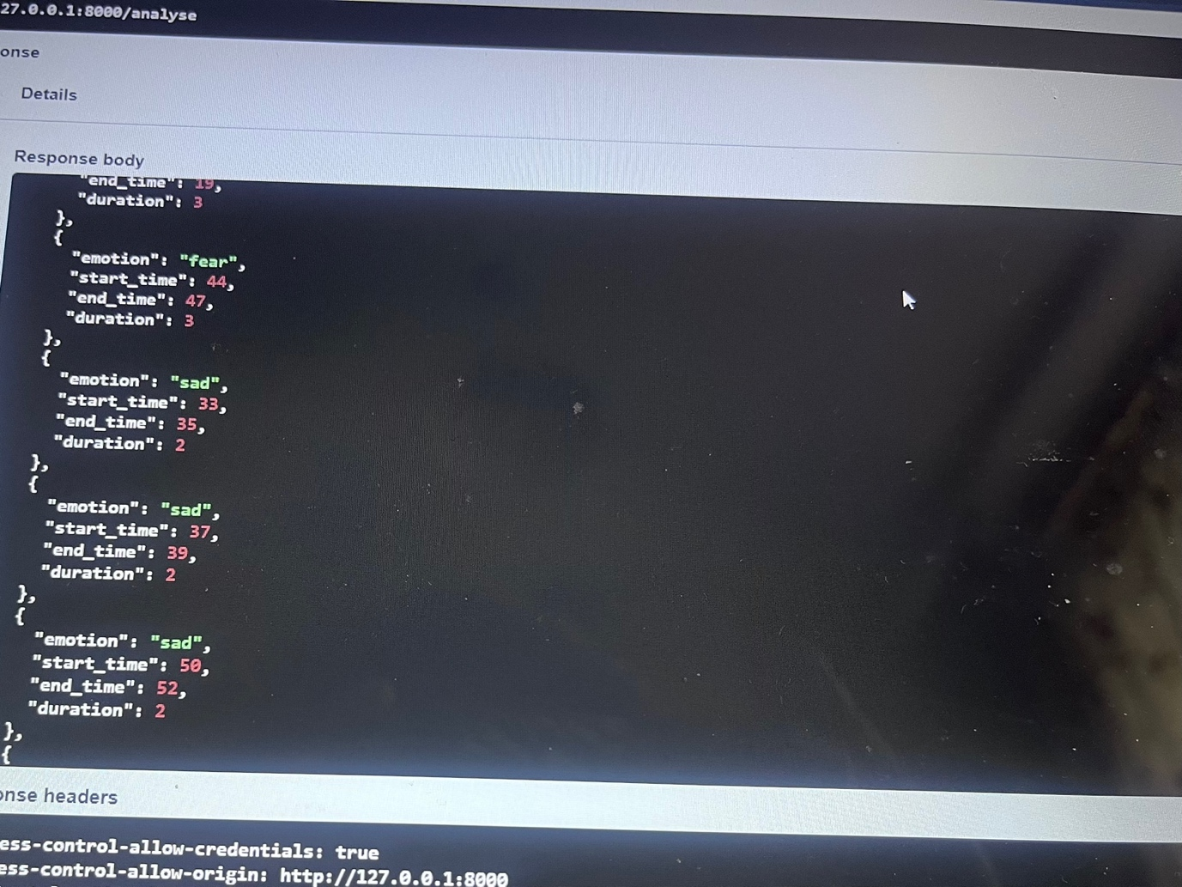
A better methodology consistent of:
- Duration (how long the emotion lasts)
- Intensity (confidence score of the emotion)
- Consistency (stability across frames)
This allows the system to find more meaningful peak emotions rather than picking clips solely on length.


6.6 Clip Generation:
The core output of this project is the clip generation, turning the video into short meaningful clip that would be deemed useful to post on different social media platforms. It’s main objective is to extract each emotion segment automatically, turn each segment into short from content, better user interaction with engaging clips and ready to use clips for social media sharing.

How Clip Generation is Applied:

This is data driven and based on emotion analysation and content generation.

Step 1: Input Video Processing:
Once a YouTube video is downloaded and confirmed to be less than the 5-minute requirement it then is looked at frame by frame. Each frame then gets given an emotion label.
Step 2: Emotion Timeline:
The system builds an emotion timeline by identifying frames at one second stops throughout the video.

0s → neutral
1s → sad
2s → sad
3s → sad
4s → happy

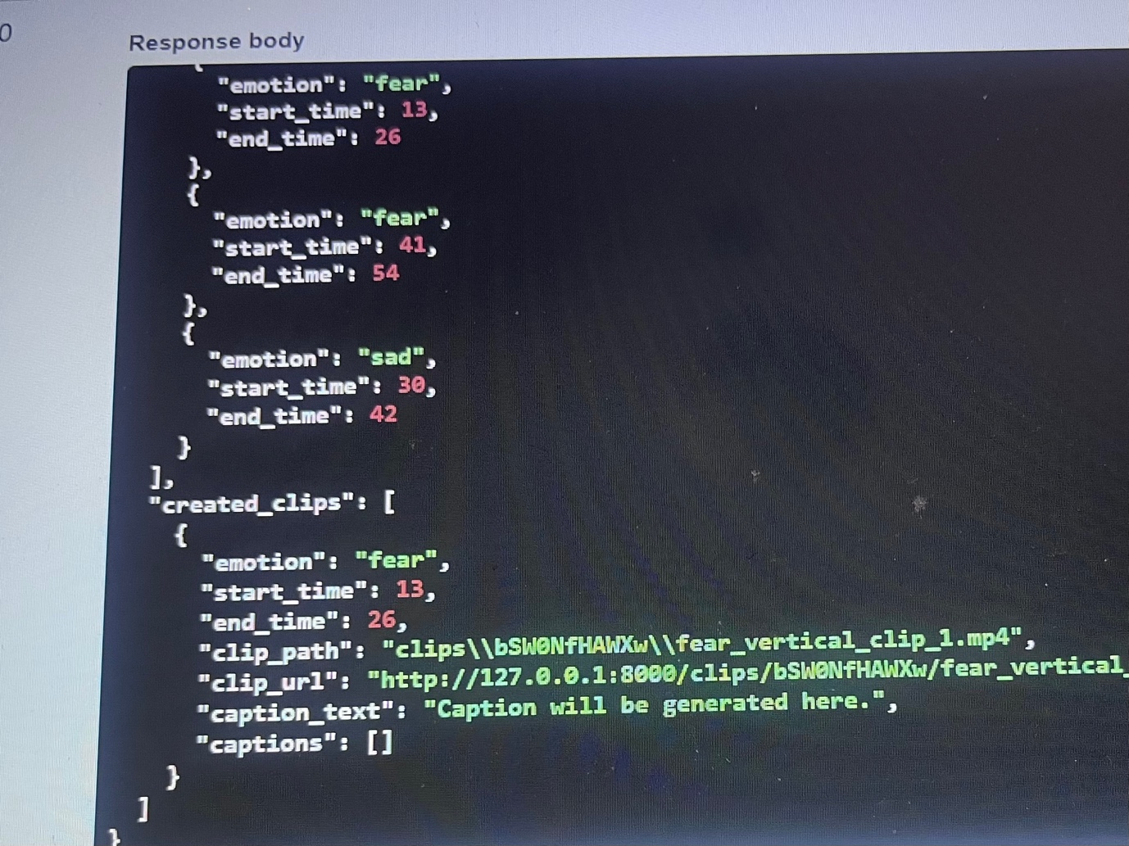
Each emotion is mapped and pointed at certain timestamps through the video
Step 3: Emotion Segment:
Frames with the same emotion are categorised into emotion segments

{
"emotion": "sad",
"start_time": 1,
"end_time": 4
}
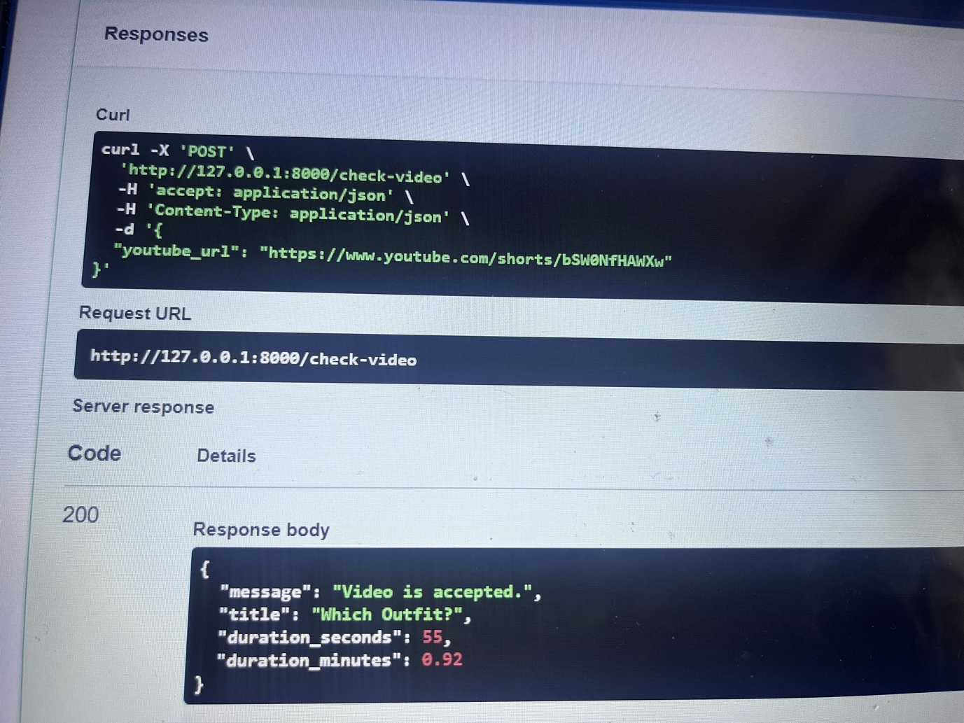
Step 4: Clip Selection:
The system chooses the most relevant segments based on
- Duration (how long the emotion lasts)
- Intensity (confidence score of the emotion)
- Consistency (stability across frames)

Chapter 7 – Conclusion and Future Work

7.1 Conclusion:
This project set out to develop a system that could be automated which could change YouTube videos into short clips purely based on emotion detected. The Emotion Clips Generator as known as Clipzz, can combine multiple technologies such as Reat for the frontend, FastApi for the backend, DeepFace used for emotion detection MoviePy used for video processing and Whisper used for caption generation.
The system can reach its main goal by allowing user to put a YouTube link less than 5 minutes, analysing the video automatically, identifying emotion over time and creating short clips suitable for social media platforms such as TikTok, YouTube Shorts and Instagram Reels. This showcases artificial intelligence in a practical way inside of content creation and automation in social media.
This project can highlight a successful use of multi-processing pipeline, including downloading videos, extraction of frames, classification of emotions and caption generation. The integration of frontend and backend components was reached giving a smooth transition from input to output by the user.
What was found was context of generated clips are highly dependent on the quality of the emotion uncovered and its logic to select emotional peaks. The system focuses on emotional segments that are long instead of emotions that could have an impact as in certain cases this can reduce the quality of its output. In addition to these discoveries is that audio ana facial transcriptions can affect the caption generator and identifier for the emotions.
Despite the limitations given, the system allows for automated emotion video editing. It showcases the effort in reducing manual responsibility in content creation in modern digital platforms.
7.2 Future Work:
Even though the core objectives are met several enhancements can be achieved to better performance and accuracy in identifying emotions.
- Improved Emotion Detection Accuracy:
- Ensuring faces are detected clearly before analysing emotions
- Neutral emotions are ignored
- More parameters to filter weak emotions and predictions
- Performance Optimisation
- Number of frames analysed are reduced
- Better GPU speed
- User Account and Cloud Storage
- Storage could be saved on user’s cloud
- User can see their history and saved projects

7.3 Final Remarks

In conclusion, the Emotion Clips Generator showcases the practicality of working machine learning, video processing and clip generation together. Even while is huge room for improvement, the systems allows for a solid basis for further development and brings awareness of the potential of AI-driven tools in modern media
References:

- Khalifa, O.O., 2025. Generative AI For Beginners: Beyond Boundaries. Othman Omran Khalifa.

- Wang, J., Jiang, H., Liu, Y., Ma, C., Zhang, X., Pan, Y., Liu, M., Gu, P., Xia, S., Li, W. and Zhang, Y., 2024. A comprehensive review of multimodal large language models: Performance and challenges across different tasks. arXiv preprint arXiv:2408.01319.

- Lin, W., 2024. The Application of Real-time Emotion Recognition in Video Conferencing. Journal of Computer Technology and Applied Mathematics, 1(4), pp.79-88.

- Hussain, M., Chen, C., Hussain, M., Anwar, M., Abaker, M., Abdelmaboud, A. and Yamin, I., 2025. Optimised knowledge distillation for efficient social media emotion recognition using DistilBERT and ALBERT. Scientific Reports, 15(1), p.30104.

- Bommasani, R., Hudson, D.A., Adeli, E., Altman, R., Arora, S., von Arx, S., Bernstein, M.S., Bohg, J., Bosselut, A., Brunskill, E. and Brynjolfsson, E. (2024) On the opportunities and risks of foundation models. Stanford University.

- Chen, G. and Han, Z. (2025) The rise of deep learning: AI and engineering applications under the spotlight of the 2024 Nobel Prize. Intelligent Geoscience.

- Azizov, D., et al. (2024) A decade of deep learning: A survey on the magnificent seven. arXiv preprint arXiv:2412.16188.

- Kaur, D., et al. (2024) Survey on systematic analysis of deep learning models compared to machine learning.

- Sharma, R., et al. (2024) Sentiment analysis using machine learning and deep learning.

- Tian, C. (2025) A survey on deep learning fundamentals and applications. Artificial Intelligence Review.

- Hu, X., et al. (2025) Multimodal emotion recognition for intelligent systems. arXiv.

Literature Review – References

- Yekta, M.M.J. (2024) ‘The general intelligence of GPT-4, its knowledge diffusive and societal influences, and its governance’, Meta-Radiology, 2(2), p. 100078. doi: 10.1016/j.metrad.2024.100078.

- Paul, S. (2024) ‘A comprehensive review on machine learning-based approaches for next-generation wireless network’, SN Computer Science, 5, p. 468. doi: 10.1007/s42979-024-02831-3.

- Lan, X. et al. (2025) From shallow to deep: The evolution of machine learning and mechanistic model integration.

- Sharma, A. et al. (2024) ‘Advances in AI and machine learning for predictive medicine’, Journal of Human Genetics. doi: (add DOI if available).

- Prabhu, M. et al. (2024) Future horizons: Key trends shaping the evolution of machine learning.

- Castaño, E. et al. (2025) ‘How do machine learning models change? A large-scale analysis of code repositories’.

- Chen, Y. and Han, J. (2025) The rise of deep learning: AI and engineering applications.

- Zhou, E. and Lee, D. (2024) ‘Generative artificial intelligence, human creativity, and art’, PNAS Nexus, 3(3), pp. 1–8. doi: 10.1093/pnasnexus/pgae052.

- Pandy, G., Pugazhenthi, V.J. and Murugan, A. (2025) ‘Generative AI: Transforming the landscape of creativity and automation’, International Journal of Computer Applications, 186(63), pp. 7–13. doi: 10.5120/ijca2025924392.

- Habib, S., Vogel, T., Anli, X. and Thorne, E. (2024) ‘How does generative artificial intelligence impact student creativity?’, Journal of Creativity, 34(1), p. 100072. doi: 10.1016/j.yjoc.2023.100072.

- Marrone, R., Cropley, D. and Medeiros, K. (2024) ‘How does narrow AI impact human creativity?’, Creativity Research Journal, pp. 1–11. doi: 10.1080/10400419.2024.2378264.

- Brem, A. and Hörauf, D. (2025) ‘Artificial creativity? AI’s short- and long-term impact on creativity’, Research-Technology Management, 68(2), pp. 54–58. doi: 10.1080/08956308.2025.2450756.

- Ivcevic, Z. (2024) ‘Artificial intelligence as a tool for creativity’, Personality and Cognitive Psychology Bulletin, 25, pp. 1–12.

- Doshi, A.R. et al. (2024) ‘Generative AI enhances individual creativity but reduces idea diversity’, Science Advances, 10(24), pp. 1–10.

- Holzner, N., Maier, S. and Feuerriegel, S. (2025) ‘Generative AI and creativity: A systematic literature review and meta-analysis’, arXiv preprint, arXiv:2505.17241.

- Salimans, T. (2024) ‘Emerging capabilities in next-generation generative models’, arXiv preprint, arXiv:2401.00012.

- Bai, Y. et al. (2024) ‘Agentic AI: Towards autonomous, reasoning-based systems’, Anthropic Research.

- Floridi, L. (2024) ‘AI agency and accountability in the age of generative models’, AI Ethics.

- Lorenz-Spreen, P. et al. (2024) ‘Risks of generative AI for information ecosystems’, Nature Human Behaviour.

- Kovačević, J. et al. (2025) ‘Sustainability, bias, and accessibility challenges in large-scale AI systems’, ACM Computing Surveys.

